**HTML**

**(1) REGISTRATION FORM**

**CODE->**

**<!DOCTYPE html>**

**<html lang="en">**

**<head>**

**<meta charset="UTF-8">**

**<meta http-equiv="X-UA-Compatible" content="IE=edge">**

**<meta name="viewport" content="width=device-width, initial-scale=1.0">**

**<title>Document</title>**

**<style>**

**form {**

**width: 37%;**

**margin-left: 360px;**

**margin-right: 350px;**

**margin-top: 50px;**

**align-self: center;**

**border: 2px solid black;**

**padding-top: 20px;**

**padding-left: 70px;**

**padding-bottom: 20PX;**

**}**

**p {**

**margin-left: 130px;**

**align-self: center;**

**font-size: 20px;**

**font-family: Arial;**

**}**

**label {**

**color: black;**

**float: left;**

**font-size: 13px;**

**line-height: 18px;**

**padding-top: 6px;**

**text-align: right;**

**width: 130px;**

**}**

**label,**

**input,**

**select,**

**textarea {**

**font-family: "Helvetica Neue", Helvetica, Arial, sans-serif;**

**font-size: 13px;**

**font-weight: normal;**

**line-height: normal;**

**}**

**input,**

**textarea,**

**select {**

**border: 1px solid black;**

**display: inline-block;**

**font-size: 13px;**

**height: 12px;**

**line-height: 12px;**

**padding: 4px;**

**width: 210px;**

**}**

**form .input {**

**margin-left: 150px;**

**}**

**form .line {**

**margin-bottom: 10px;**

**}**

**</style>**

**</head>**

**<body>**

**<form >**

**<p><b>Registration Form</b></p>**

**<div class="line">**

**<label for="input">Username</label>**

**<div class="input">**

**<input type="text" size="30" name="input">**

**</div>**

**</div>**

**<div class="line">**

**<label for="input">Password</label>**

**<div class="input">**

**<input type="text" size="30" name="input">**

**</div>**

**</div>**

**<div class="line">**

**<label for="input">Confirm Password</label>**

**<div class="input">**

**<input type="text" size="30" name="input">**

**</div>**

**</div>**

**<div class="line">**

**<label for="input">FirstName</label>**

**<div class="input">**

**<input type="text" size="30" name="input">**

**</div>**

**</div>**

**<div class="line">**

**<label for="input">LastName</label>**

**<div class="input">**

**<input type="text" name="input">**

**</div>**

**</div>**

**<div class="line">**

**<label for="input">Email</label>**

**<div class="input">**

**<input type="text" name="input">**

**</div>**

**</div>**

**<div class="line">**

**<label for="input">Phone Number </label>**

**<div class="input">**

**<input type="text" name="input">**

**</div>**

**</div>**

**<div class="line">**

**<label for="input">Location</label>**

**<div class="input">**

**<input type="text" name="input">**

**</div>**

**</div>**

**&nbsp;&nbsp;&nbsp;&nbsp;<button type="submit" value="submit">Submit</button>**

**&nbsp;&nbsp;&nbsp;&nbsp;&nbsp;<button type="reset" value="reset">Reset</button>**

**</form>**

**</body>**

**</html>**

**OUTPUT->**

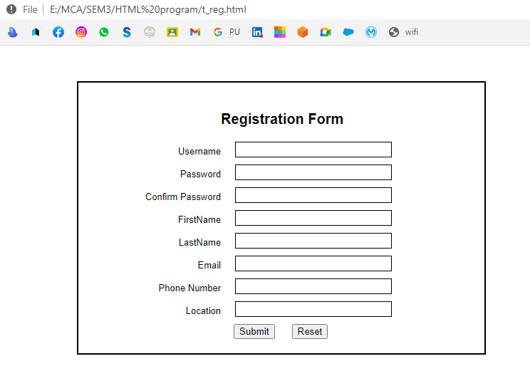

**(2) POPULATION CHART**

**CODE->**

**<!DOCTYPE html>**

**<html lang="en">**

**<head>**

**<meta charset="UTF-8">**

**<meta http-equiv="X-UA-Compatible" content="IE=edge">**

**<meta name="viewport" content="width=device-width, initial-scale=1.0">**

**<title>Assignment_Table</title>**

**<style>**

**table {**

**width: 40%;**

**margin-top: 50px;**

**margin-left: auto;**

**margin-right: auto;**

**}**

**table,**

**th,**

**td {**

**border: 2px solid black;**

**}**

**th {**

**text-align: center;**

**}**

**td {**

**text-align: right;**

**}**

**th,**

**td {**

**padding-bottom: 5px;**

**background-color: white;**

**padding-right: 15px;**

**}**

**table {**

**border-collapse: collapse;**

**}**

**</style>**

**</head>**

**<body>**

**<br>**

**<br>**

**<table >**

**<thead >**

**<tr>**

**<th>Country</th>**

**<th colspan="2" >Population(In Crores)</th>**

**</tr>**

**</thead>**

**<tbody >**

**<tr>**

**<td rowspan="3">INDIA</td>**

**<td>1998</td>**

**<td>85</td>**

**</tr>**

**<tr>**

**<td>1999</td>**

**<td>90</td>**

**</tr>**

**<tr>**

**<td>2000</td>**

**<td>100</td>**

**</tr>**

**<tr>**

**<td rowspan="3">USA</td>**

**<td>1998</td>**

**<td>30</td>**

**</tr>**

**<tr>**

**<td>1999</td>**

**<td>35</td>**

**</tr>**

**<tr>**

**<td>2000</td>**

**<td>40</td>**

**</tr>**

**<tr>**

**<td rowspan="3">UK</td>**

**<td>1998</td>**

**<td>25</td>**

**</tr>**

**<tr>**

**<td>1999</td>**

**<td>30</td>**

**</tr>**

**<tr>**

**<td>2000</td>**

**<td>35</td>**

**</tr>**

**</tbody>**

**</table>**

**</body>**

**</html>**

**OUTPUT->**

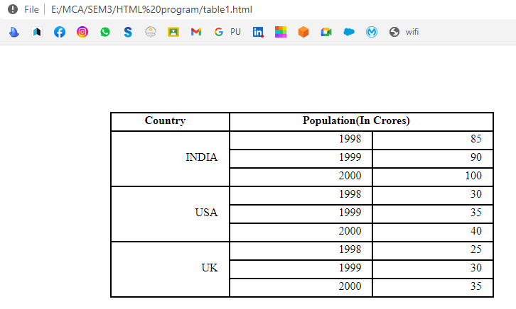

**(3) MAIL SENDING**

**CODE->**

**<!DOCTYPE html>**

**<html lang="en">**

**<head>**

**<meta charset="UTF-8">**

**<meta http-equiv="X-UA-Compatible" content="IE=edge">**

**<meta name="viewport" content="width=device-width, initial-scale=1.0">**

**<title>Ass2_form</title>**

**<style>**

**form{**

**margin-top: 56px;**

**margin-bottom: 56px;**

**margin-left: 350px;**

**margin-right: 250px;**

**padding-top: 36px;**

**padding-bottom: 36px;**

**padding-left: 35px;**

**padding-right: 30px;**

**background-color:white;**

**width: 35%;**

**border: 3px solid black;**

**}**

**button{**

**padding: 5px 6px 5px 6px;**

**background-color:white;**

**}**

**#myfile{**

**background-color:white;**

**}**

**</style>**

**</head>**

**<body >**

**<form>**

**<div>**

**<label for="Username">Enter Name of your friend &nbsp;&nbsp;&nbsp;&nbsp;&nbsp;**

**&nbsp;&nbsp;&nbsp;</label>**

**<input type="text" name="text">**

**</div>**

**<br>**

**<div>**

**<label for="myfile"> Choose the file you want to post to your friend</label><br>**

**<input type = text name="file">&nbsp;&nbsp;&nbsp;**

**<input type="file" id="myfile" name="Browse">**

**</div>**

**<br>**

**<div>**

**<label for="checkbox">What does the file contain ?</label><br>**

**<input type="checkbox" id="check" >Image**

**<input type="checkbox" id="check">Source code**

**<input type="checkbox" id="check">Binary code**

**</div>**

**<br>**

**<div>**

**&nbsp;&nbsp;<label for="Submit">You have Completed the form</label>**

**&nbsp;&nbsp;&nbsp;**

**<button>Submit Query</button>**

**</div>**

**</form>**

**</body>**

**</html>**

**OUTPUT->**

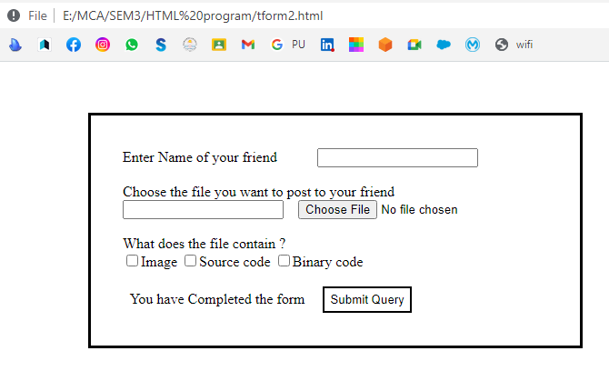

**(4) WARNING**

**CODE->**

**<!DOCTYPE html>**

**<html lang="en">**

**<head>**

**<meta charset="UTF-8">**

**<meta http-equiv="X-UA-Compatible" content="IE=edge">**

**<meta name="viewport" content="width=device-width, initial-scale=1.0">**

**<title>Warning</title>**

**<style>**

**body{**

**background-color: red;**

**}**

**.blink{**

**animation: blink 2s linear infinite;**

**font-size:xx-large;**

**margin-top: 50px;**

**text-align: center;**

**}**

**@keyframes blink {**

**50%{**

**opacity: 20%;**

**}**

**}**

**</style>**

**</head>**

**<body >**

**<h1 class="blink">Warning</h1>**

**<marquee direction="left" >marquee text in its default direction</marquee>**

**</body>**

**</html>**

**OUTPUT->**

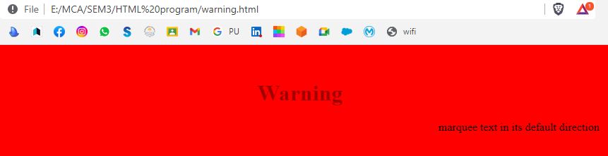

**(5) FREM_SET**

**CODE->**

**<!DOCTYPE html>**

**<html lang="en">**

**<head>**

**<meta charset="UTF-8">**

**<meta http-equiv="X-UA-Compatible" content="IE=edge">**

**<meta name="viewport" content="width=device-width, initial-scale=1.0">**

**<title>Frameset2</title>**

**</head>**

**<Frameset rows="30%, 70% " class="container">**

**<frame src = "frm2_row1.html"></frame>**

**<Frameset cols="50%,50%">**

**<frame src="frm2_row2_col1.html"></frame>**

**<frame src="frm2_row2_col2.html"></frame>**

**</Frameset>**

**</Frameset>**

**</html>**

**<----frm2_row1.html-------->**

**<!DOCTYPE html>**

**<html lang="en">**

**<head>**

**<meta charset="UTF-8">**

**<meta http-equiv="X-UA-Compatible" content="IE=edge">**

**<meta name="viewport" content="width=device-width, initial-scale=1.0">**

**<title>Document</title>**

**<style>**

**body{**

**background-color: red;**

**color: white;**

**font-family: Georgia;**

**margin-top: 25px;**

**font-size:xx-large;**

**}**

**</style>**

**</head>**

**<body >**

**<h1 align="center">**

**<b>Top Frame</b>**

**</h1>**

**</body>**

**</html>**

**<----frm2_row2_col1.html---->**

**<!DOCTYPE html>**

**<html lang="en">**

**<head>**

**<meta charset="UTF-8">**

**<meta http-equiv="X-UA-Compatible" content="IE=edge">**

**<meta name="viewport" content="width=device-width, initial-scale=1.0">**

**<title>Document</title>**

**<style>**

**body{**

**background-color:darkorange;**

**color: white;**

**font-family: Georgia;**

**margin-top: 150px;**

**font-size:xx-large;**

**}**

**h1{**

**text-align: center;**

**}**

**</style>**

**</head>**

**<body>**

**<h1>**

**<b>Left Frame</b>**

**</h1>**

**</body>**

**</html>**

**<----frm2_row2_col2.html---->**

**<!DOCTYPE html>**

**<html lang="en">**

**<head>**

**<meta charset="UTF-8">**

**<meta http-equiv="X-UA-Compatible" content="IE=edge">**

**<meta name="viewport" content="width=device-width, initial-scale=1.0">**

**<title>Document</title>**

**<style>**

**body{**

**background-color:darkorange;**

**color: white;**

**font-family: Georgia;**

**margin-top: 150px;**

**font-size:xx-large;**

**}**

**h1{**

**text-align: center;**

**}**

**</style>**

**</head>**

**<body>**

**<h1>**

**<b>Right Frame</b>**

**</h1>**

**</body>**

**</html>**

**OUTPUT->**

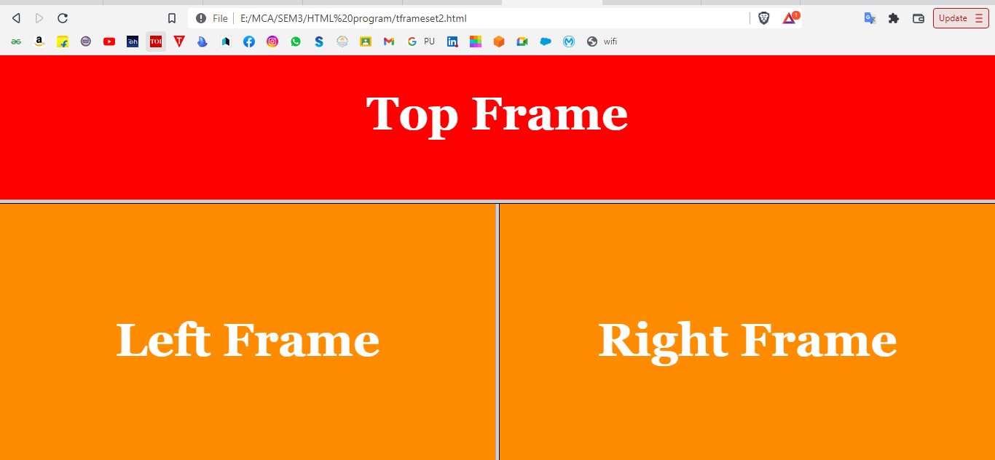

**CSS**

**(1) University survey form**

**HTML CODE->**

**<!DOCTYPE html>**

**<html lang="en">**

**<head>**

**<meta charset="UTF-8">**

**<meta http-equiv="X-UA-Compatible" content="IE=edge">**

**<meta name="viewport" content=**

**"width=device-width, initial-scale=1.0">**

**<title>Survey Form </title>**

**<link rel="stylesheet" href="CSS_ASS1.css">**

**</head>**

**<body>**

**<h1>Pondicherry University Survey Form</h1>**

**<form id="form">**

**<div class="form-control">**

**<label for="name" id="label-name">**

**Name**

**</label>**

**<input type="text"**

**id="name"**

**placeholder="Enter your name" />**

**</div>**

**<div class="form-control">**

**<label for="email" id="label-email">**

**Email**

**</label>**

**<input type="email"**

**id="email"**

**placeholder="Enter your email" />**

**</div>**

**<div class="form-control">**

**<label for="Department" id="label-Department">**

**Department**

**</label>**

**<input type="text"**

**id="label-Department"**

**placeholder="Enter your Department" />**

**</div>**

**<div class="form-control">**

**<label for="Course" id="label-Course">**

**Course**

**</label>**

**<input type="text"**

**id="label-Course"**

**placeholder="Enter your Course" />**

**</div>**

**<div class="form-control">**

**<label for="role" id="label-role">**

**How do you know about Pondicherry University?**

**</label>**

**<select name="role" id="role">**

**<option value="By Friend">By Friends</option>**

**<option value="intern">Intern</option>**

**<option value="Advertisement">**

**Advertisement**

**</option>**

**<option value="other">Other</option>**

**</select>**

**</div>**

**<div class="form-control">**

**<label>**

**Would you recommend Pondicherry University**

**to a friend?**

**</label>**

**<label for="recommed-1">**

**<input type="radio"**

**id="recommed-1"**

**name="recommed">Yes</input>**

**</label>**

**<label for="recommed-2">**

**<input type="radio"**

**id="recommed-2"**

**name="recommed">No</input>**

**</label>**

**<label for="recommed-3">**

**<input type="radio"**

**id="recommed-3"**

**name="recommed">Maybe</input>**

**</label>**

**</div>**

**<div class="form-control">**

**<label for="comment">**

**Any comments or suggestions**

**</label>**

**<textarea name="comment" id="comment"**

**placeholder="Enter your comment here">**

**</textarea>**

**</div>**

**<button type="submit" value="submit">**

**Submit**

**</button>**

**</form>**

**</body>**

**</html>**

**CSS CODE->**

**body {**

**background-color: lightsalmon;**

**font-family: Verdana;**

**text-align: center;**

**}**

**form {**

**background-color: lightskyblue;**

**max-width: 500px;**

**margin: 50px auto;**

**padding: 30px 20px;**

**box-shadow: 2px 5px 10px rgba(0, 0, 0, 0.5);**

**}**

**.form-control {**

**text-align: left;**

**margin-bottom: 25px;**

**}**

**.form-control label {**

**display: block;**

**margin-bottom: 10px;**

**}**

**.form-control input,**

**.form-control select,**

**.form-control textarea {**

**border: 1px solid #777;**

**border-radius: 2px;**

**font-family: inherit;**

**padding: 10px;**

**display: block;**

**width: 95%;**

**}**

**.form-control input[type="radio"],**

**.form-control input[type="checkbox"] {**

**display: inline-block;**

**width: auto;**

**}**

**button {**

**background-color: #05c46b;**

**border: 1px solid #777;**

**border-radius: 2px;**

**font-family: inherit;**

**font-size: 21px;**

**display: block;**

**width: 100%;**

**margin-top: 50px;**

**margin-bottom: 20px;**

**}**

**Output->**

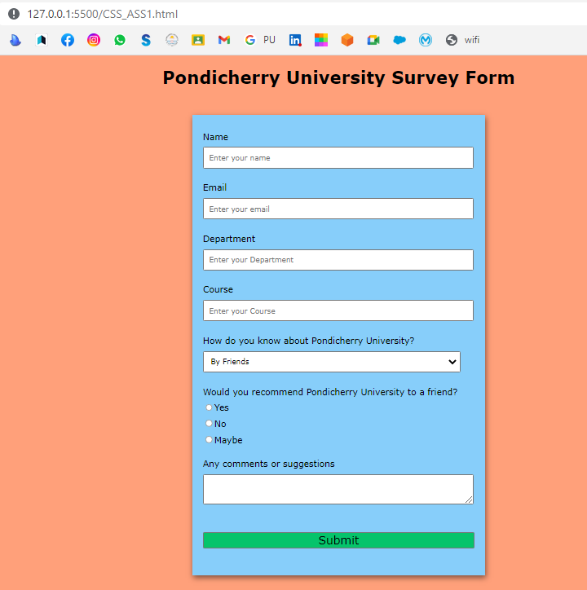

## (2) Responsive Form

**HTML CODE->**

**<!DOCTYPE html>**

**<html>**

**<head>**

**<meta charset="UTF-8">**

**<meta http-equiv="X-UA-Compatible" content="IE=edge">**

**<meta name="viewport" content=**

**"width=device-width, initial-scale=1.0">**

**<title>Responsive Form </title>**

**<link rel="stylesheet" href="CSS_ASS3.css">**

**</head>**

**<body>**

**<h2>Responsive Form</h2>**

**<div class="container">**

**<form action="/action_page.php">**

**<div class="row">**

**<div class="col-25">**

**<label for="fname">First Name</label>**

**</div>**

**<div class="col-75">**

**<input type="text" id="fname" name="firstname" placeholder="Your name..">**

**</div>**

**</div>**

**<div class="row">**

**<div class="col-25">**

**<label for="lname">Last Name</label>**

**</div>**

**<div class="col-75">**

**<input type="text" id="lname" name="lastname" placeholder="Your last name..">**

**</div>**

**</div>**

**<div class="row">**

**<div class="col-25">**

**<label for="country">Country</label>**

**</div>**

**<div class="col-75">**

**<select id="country" name="country">**

**<option value="australia">India</option>**

**<option value="australia">Australia</option>**

**<option value="canada">Canada</option>**

**<option value="usa">USA</option>**

**</select>**

**</div>**

**</div>**

**<div class="row">**

**<div class="col-25">**

**<label for="subject">Subject</label>**

**</div>**

**<div class="col-75">**

**<textarea id="subject" name="subject" placeholder="Write something.." style="height:200px"></textarea>**

**</div>**

**</div>**

**<br>**

**<div class="row">**

**<input type="submit" value="Submit">**

**</div>**

**</form>**

**</div>**

**</body>**

**</html>**

**CSS CODE->**

**\* {**

**box-sizing: border-box;**

**}**

**input[type=text], select, textarea {**

**width: 100%;**

**padding: 12px;**

**border: 1px solid #ccc;**

**border-radius: 4px;**

**resize: vertical;**

**}**

**label {**

**padding: 12px 12px 12px 0;**

**display: inline-block;**

**}**

**input[type=submit] {**

**background-color: #04AA6D;**

**color: white;**

**padding: 12px 20px;**

**border: none;**

**border-radius: 4px;**

**cursor: pointer;**

**float: right;**

**}**

**input[type=submit]:hover {**

**background-color: #45a049;**

**}**

**.container {**

**border-radius: 5px;**

**background-color: #f2f2f2;**

**padding: 20px;**

**}**

**.col-25 {**

**float: left;**

**width: 25%;**

**margin-top: 6px;**

**}**

**.col-75 {**

**float: left;**

**width: 75%;**

**margin-top: 6px;**

**}**

**.row:after {**

**content: "";**

**display: table;**

**clear: both;**

**}**

**@media screen and (max-width: 600px) {**

**.col-25, .col-75, input[type=submit] {**

**width: 100%;**

**margin-top: 0;**

**}**

**}**

**OUTPUT->**

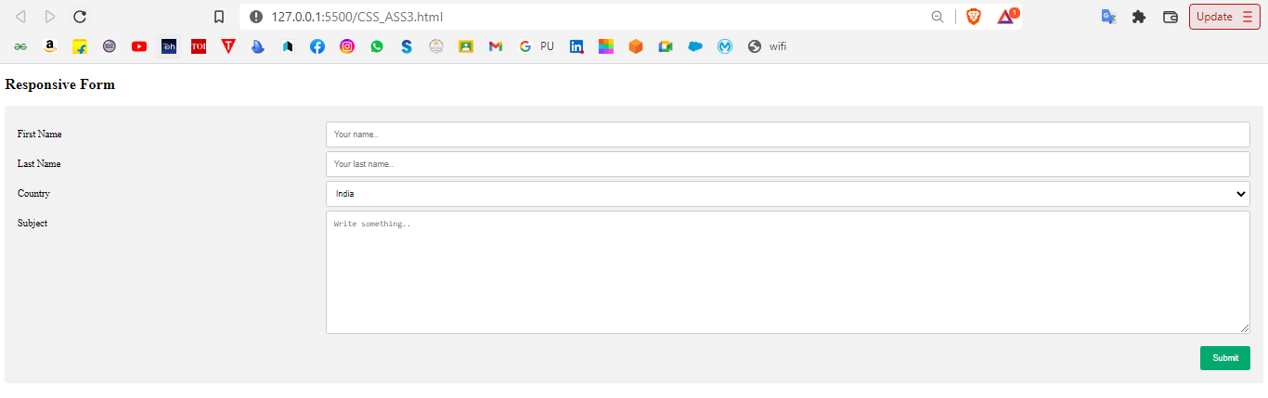

## (3) Responsive Form

**HTML CODE->**

**<!DOCTYPE html>**

**<html lang="en">**

**<head>**

**<meta charset="UTF-8">**

**<meta http-equiv="X-UA-Compatible" content="IE=edge">**

**<meta name="viewport" content=**

**"width=device-width, initial-scale=1.0">**

**<title>Tribute Page </title>**

**<link rel="stylesheet" href="CSS_ASS2.css">**

**</head>**

**<body>**

**<main id="main">**

**<h1 id="title">**

**A. P. J. Abdul Kalam**

**</h1>**

**<div id="img">**

**<img src="a-p-j-abdul-kalam.jpg" id="image"**

**alt="Error Loading Image">**

**<small id="caption">**

**Great Indian scientist and**

**politician who played a leading**

**role in the development of India’s**

**missile and nuclear weapons**

**programs.**

**</small>**

**</div>**

**<div id="tribute-data">**

**<h1 class="title-APJ">**

**About the Legend**

**</h1>**

**<p>**

**☛ A.P.J. Abdul Kalam, in full**

**Avul Pakir Jainulabdeen Abdul Kalam,**

**was born on October 15, 1931, in**

**Rameswaram, Tamil Nadu, India.<br><br>**

**☛ He served as the 11th President**

**of India from 2002 to 2007.<br><br>**

**☛ Kalam earned a degree in**

**aeronautical engineering from the**

**Madras Institute of Technology and in**

**1958 joined the Defence Research and**

**Development Organisation (DRDO).<br><br>**

**☛ In 1969, he moved to the Indian**

**Space Research Organisation, where he**

**was project director of the SLV-III, the**

**first satellite launch vehicle that was**

**both designed and produced in India.**

**<br><br> ☛ Rejoining DRDO in 1982,**

**Kalam planned the program that produced**

**a number of successful missiles, which**

**helped earn him the nickname <strong>**

**“Missile Man.”</strong>**

**<br><br> ☛ Among those successes**

**was Agni, India’s first intermediate-range**

**ballistic missile, which incorporated**

**aspects of the SLV-III and was launched**

**in 1989.**

**<br><br> ☛ He also played a**

**pivotal organisational, technical,**

**and political role in India's Pokhran-II**

**nuclear tests in 1998, the first since**

**the original nuclear test by India in 1974.**

**<br><br> ☛ From 1992 to 1997 Kalam**

**was scientific adviser to the defense**

**minister, and he later served as principal**

**scientific adviser (1999–2001) to the**

**government with the rank of cabinet minister.**

**<br><br> ☛ His prominent role in**

**the country’s 1998 nuclear weapons tests**

**solidified India as a nuclear power and**

**established Kalam as a national hero,**

**although the tests caused great concern**

**in the international community.**

**<br><br> ☛ In 1998 Kalam put**

**forward a countrywide plan called**

**Technology Vision 2020, which he described**

**as a road map for transforming India from**

**a less-developed to a developed society**

**in 20 years. The plan called for, among**

**other measures, increasing agricultural**

**productivity, emphasizing technology as**

**a vehicle for economic growth, and**

**widening access to health care and**

**education.**

**<br><br> ☛ Kalam received <b>7</b>**

**honorary doctorates from <b>40</b>**

**universities. The Government of India**

**honoured him with the <b>Padma Bhushan**

**in 1981</b> and the <b>Padma Vibhushan**

**in 1990</b> for his work with ISRO and**

**DRDO and his role as a scientific advisor**

**to the Government.**

**<br><br> ☛ In 1997, Kalam received**

**India's highest civilian honour, the**

**Bharat Ratna, for his contribution to**

**the scientific research and modernisation**

**of defence technology in India.**

**<br><br> ☛ In 2013, he was the**

**recipient of the Von Braun Award from**

**the National Space Society "to recognize**

**excellence in the management and leadership**

**of a space-related project".**

**<br><br> ☛ While delivering a**

**lecture at the Indian Institute of**

**Management Shillong, Kalam collapsed and**

**died from an apparent cardiac arrest on**

**<b>27 July 2015</b>, aged 83.**

**<br><br> ☛ Wheeler Island, a**

**national missile test site in Odisha, was**

**renamed <b>Kalam Island</b> in September**

**2015.**

**<br><br> ☛ A prominent road in**

**New Delhi was renamed from Aurangzeb**

**Road to <b>Dr APJ Abdul Kalam Road</b>**

**in August 2015.**

**<br><br> ☛ In February 2018,**

**scientists from the Botanical Survey**

**of India named a newly found plant**

**species as Drypetes kalamii, in his**

**honour.**

**<br><br><br>**

**</p>**

**</div>**

**<br>**

**</main>**

**</body>**

**</html>**

**CSS CODE->**

**body {**

**background-color: rgb(56, 167, 231);**

**margin: 20%;**

**}**

**#title {**

**text-align: center;**

**text-shadow: 5px 5px 10px white;**

**font-size: 7vh;**

**}**

**img {**

**display: inline-block;**

**width: 100%;**

**}**

**#caption {**

**font-size: 17px;**

**font-family: Gill Sans;**

**color: black;**

**}**

**div#tribute-data {**

**background-color: lightcyan;**

**box-shadow: 20px 20px 20px #8efa8e;**

**font-family: Georgia;**

**padding: 25px 25px;**

**margin: 11px;**

**margin-top: 50px;**

**}**

**h1.title-APJ {**

**font-size: 35px;**

**color: white;**

**text-align: center;**

**text-shadow: 5px 5px 10px black;**

**}**

**#tribute-link {**

**text-decoration: none;**

**color: black;**

**}**

**OUTPUT->**

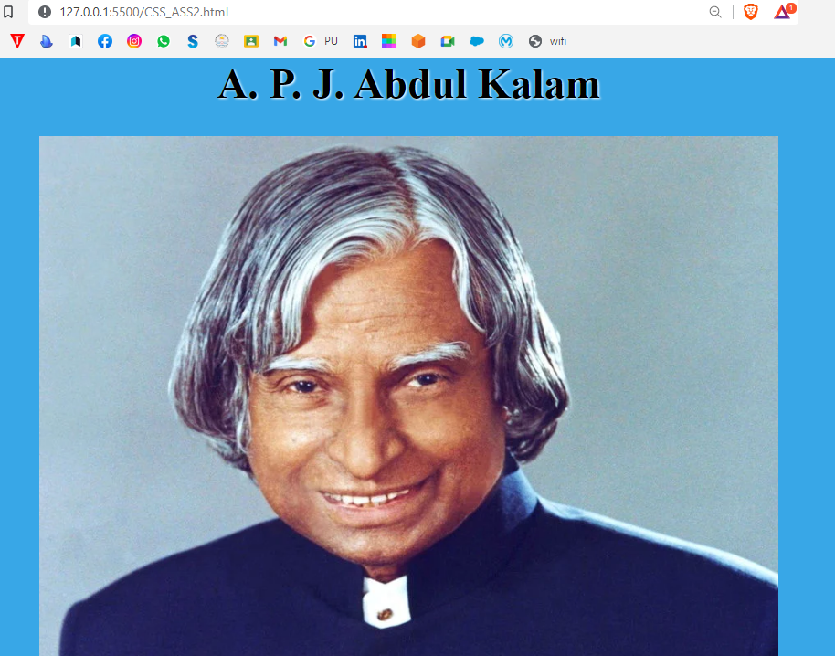

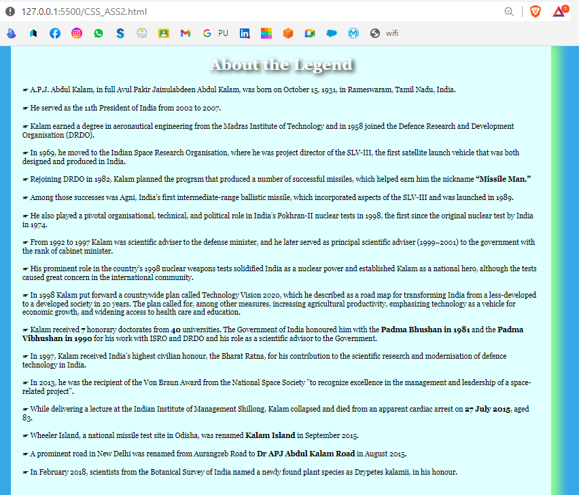

## (4) My Profile Card

**HTML CODE->**

**<!DOCTYPE html>**

**<html>**

**<head>**

**<meta charset="UTF-8">**

**<meta http-equiv="X-UA-Compatible" content="IE=edge">**

**<meta name="viewport" content=**

**"width=device-width, initial-scale=1.0">**

**<title> My Profile Card</title>**

**<link rel="stylesheet" href="CSS_ASS4.css">**

**</head>**

**<body>**

**<h2 style="text-align:center">My Profile Card</h2>**

**<div class="card">**

**<img src="rohti_pp.jpg" alt="Rohit" style="width:100%">**

**<h1>Rohit Pandey</h1>**

**<p class="title">Student in</p>**

**<p>Pondicherry University</p>**

**<div style="margin: 24px 0;">**

**<a href="https://twitter.com/login"><i class="fa fa-twitter"></i></a>**

**<a href="https://www.linkedin.com/login"><i class="fa fa-linkedin"></i></a>**

**<a href="https://www.facebook.com/"><i class="fa fa-facebook"></i></a>**

**</div>**

**<p><button>Contact</button></p>**

**</div>**

**</body>**

**</html>**

**CSS CODE->**

**.card {**

**box-shadow: 0 4px 8px 0 rgba(0, 0, 0, 0.2);**

**max-width: 300px;**

**margin: auto;**

**text-align: center;**

**font-family: arial;**

**}**

**.title {**

**color: grey;**

**font-size: 18px;**

**}**

**button {**

**border: none;**

**outline: 0;**

**display: inline-block;**

**padding: 8px;**

**color: white;**

**background-color: #000;**

**text-align: center;**

**cursor: pointer;**

**width: 100%;**

**font-size: 18px;**

**}**

**a {**

**text-decoration: none;**

**font-size: 22px;**

**color: black;**

**}**

**button:hover, a:hover {**

**opacity: 0.7;**

**}**

**OUTPUT->**

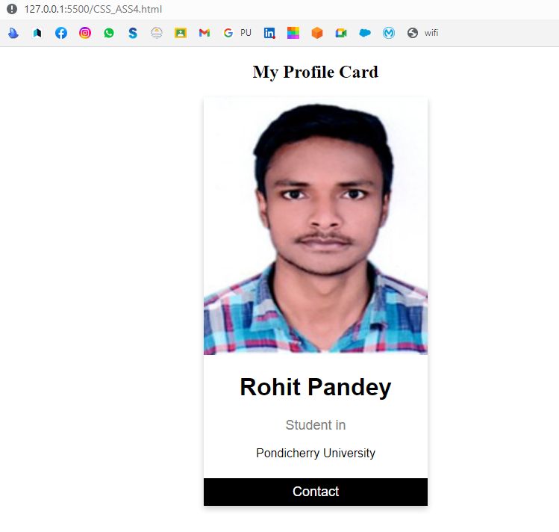

## (5) My Profile Card

**HTML CODE->**

**OUTPUT->**